NAME: ________________________________ Date: _____________ Section: ___________
Directions

- Review Presentation - 3.2.4A Hydraulic Power
- Answer the following questions by filling in the boxes with relevant info.
- Hand it in to your instructor
Example 1: Show your work
Show all work for the following questions. Highlight your answer. Images of your work can be submitted.
Three step work
Formula
Substitution
Answer

Questions

- Pascal Example:
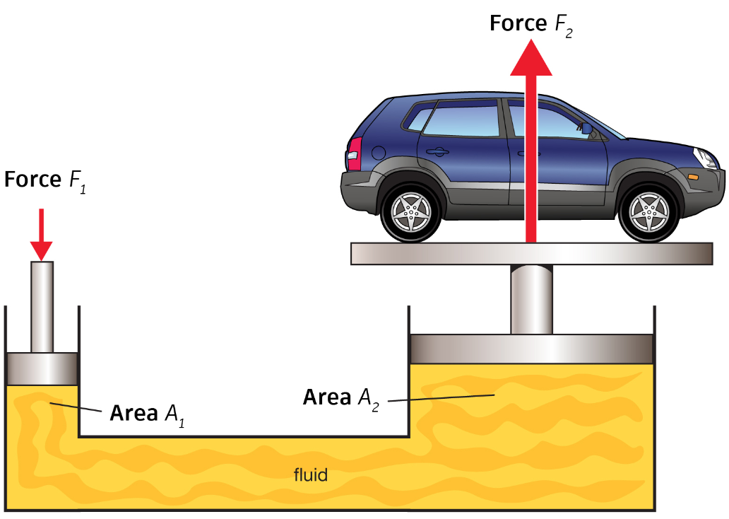 HINT: 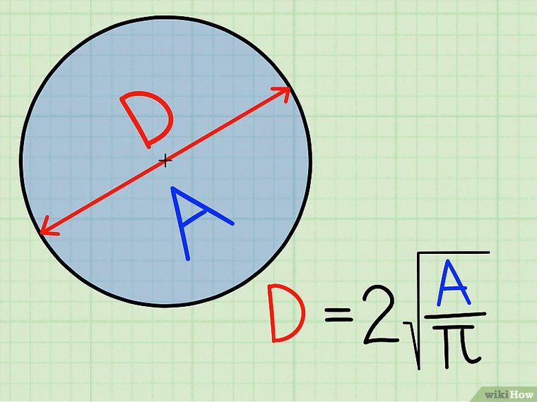
Car = Force 2 = 4000 lbs
Pump = Force 2 = 310 lbs
A2 = 8 in diameter
A1 = ?

- Pascal Example:
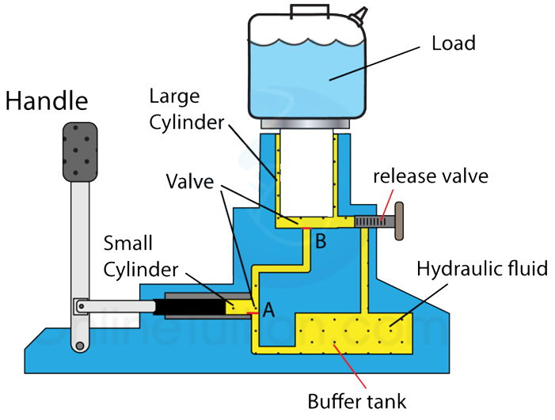
Cylinder A - Small Cylinder - Diameter of 0.57in
Cylinder B - Large Cylinder - Diameter of 1.79 in
Load - Car - 1000lb (about ¼ of the cars total weight)
How much force must be put into the small diameter cylinder to lift the car?
P=F/A

- Using the previous problem, the amount of force needed seems to be higher than the average person should need to put in. What would the diameter of the larger cylinder (B) need to be to only need an input force (user’s effort) of 10 lbs?

- Looking at the diagram and the results from the last two questions (2 & 3) what part of the diagram allows the USER to actually put in even LESS EFFORT FORCE than that needed or calculated using Pascal’s formula to lift the car?
- Part of the Diagram =
- Why? =

- CAR JACK: The user gets to put in less force to lift a heavier object….. What is the trade off of the car jack? (Hint Mechanical Advantage)

- A flow meter attached to the main line in a hydraulic system measures the flow rate at 35 gpm. The line has an inside diameter of 3 in. What is the flow velocity in the meter?

A force of 300. lbf is applied to the input cylinder of the hydraulic press seen below.
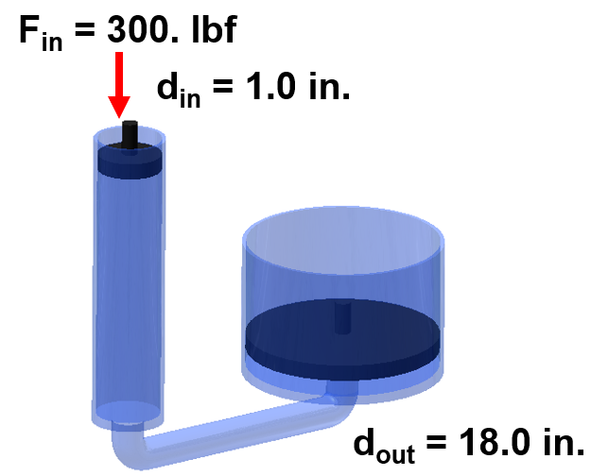
- What is the pressure in the system?
- How much force can the output cylinder lift?
- What is the mechanical advantage of the system?

