Directions: Take a snip of your part using the following rules:  Make sure your part is made of ABS Plastic  Be sure the MODEL window is open  Be sure there is an ISOMETRIC view of the part  Be sure the iProperties tab is open |  | 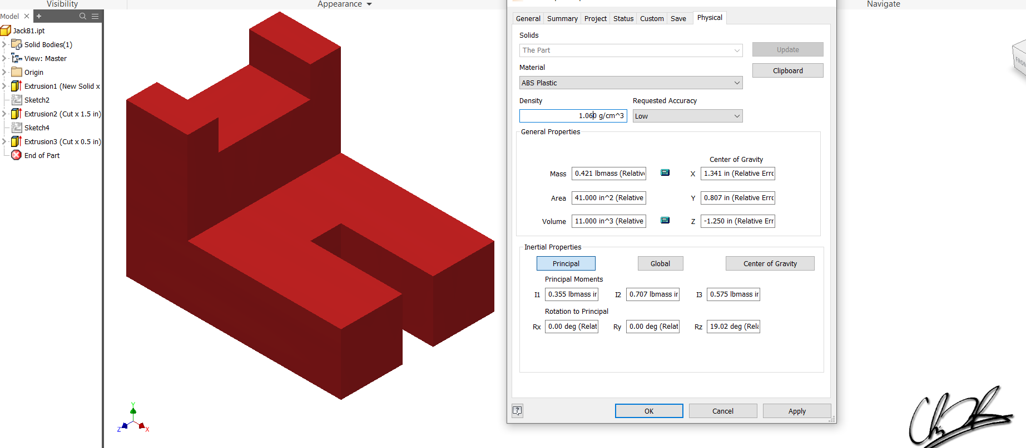  Exemplar of a good Snip!
Part #1:
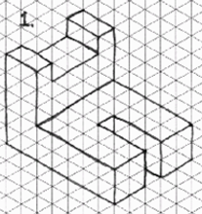 | Place the proper snip of the part file here
Part #2:
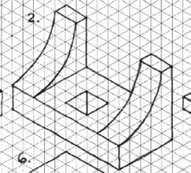 | Place the proper snip of the part file here
Part #3:
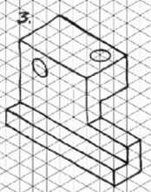 | Place the proper snip of the part file here
Part #4:
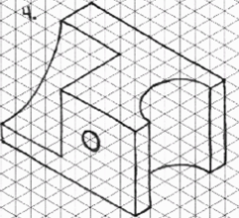 | Place the proper snip of the part file here
Part #5:
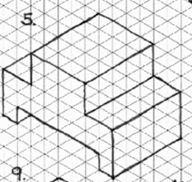 | Place the proper snip of the part file here
Part #6:
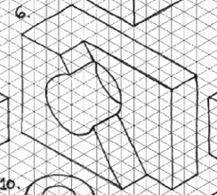 | Place the proper snip of the part file here
Part #7:
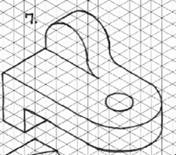 | Place the proper snip of the part file here
Part #8:
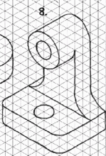 | Place the proper snip of the part file here
Part #9:
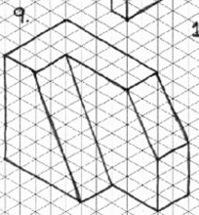 | Place the proper snip of the part file here
Part #10:
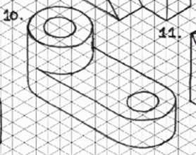 | Place the proper snip of the part file here
Part #11:
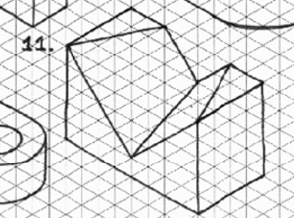 | Place the proper snip of the part file here
Going Beyond #1:
Place the proper snip of the part file here
Going Beyond #2:
Place the proper snip of the part file here
Going Beyond #3:
Place the proper snip of the part file here
Going Beyond #4:
Place the proper snip of the part file here
Going Beyond #5
Place the proper snip of the part file here

