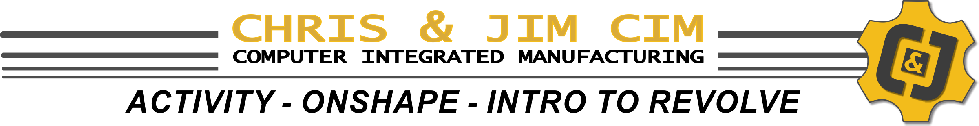

Student Name | Period / Section | Date

INSTRUCTIONS:
In the windows below, place a screen capture of your final model from the Revolve with Dimensions Video along with the mass properties information.

NOTE: You must add a custom color to your finished part before capturing your image

IMAGE of finished part in ISOMETRIC | IMAGE of mass properties (volume / surface area)

